Photo Page
Insured: Byron-Bergen CSD
Location: 6917 West Bergen Rd. Bergen, NY

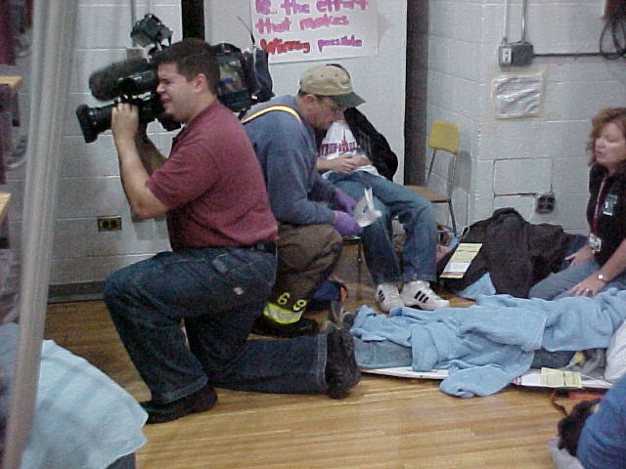 |  | 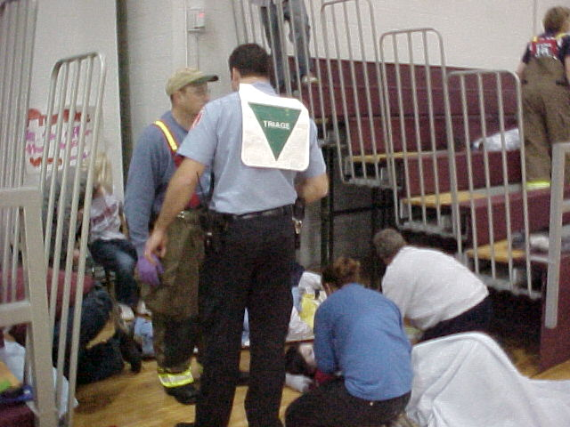
Photo 1 – Injured students being attended to. Camera man from local TV News Station |  | Photo 2 – Injured students being attended to. Triage assessing injured
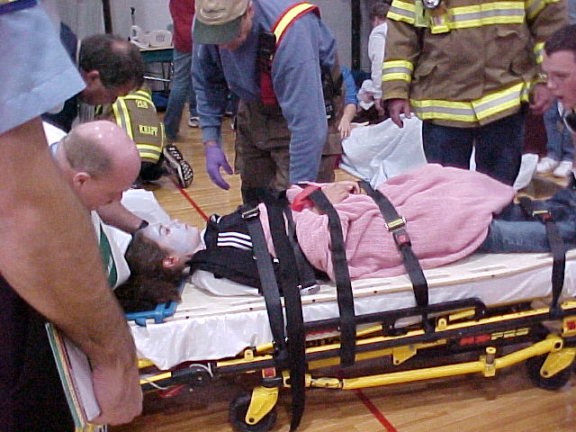 |  | 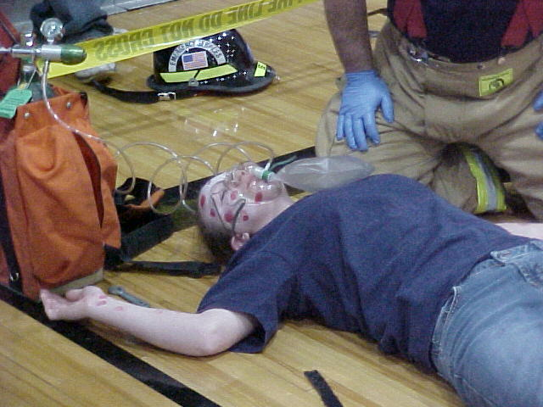
Photo 3 – Injured student on transport gurney |  | Photo 4 – Injured student being attended to.
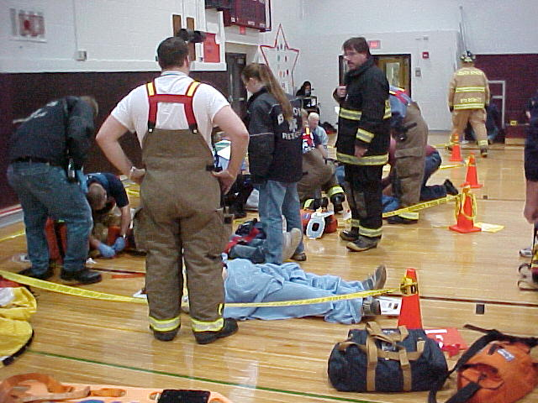 |  | 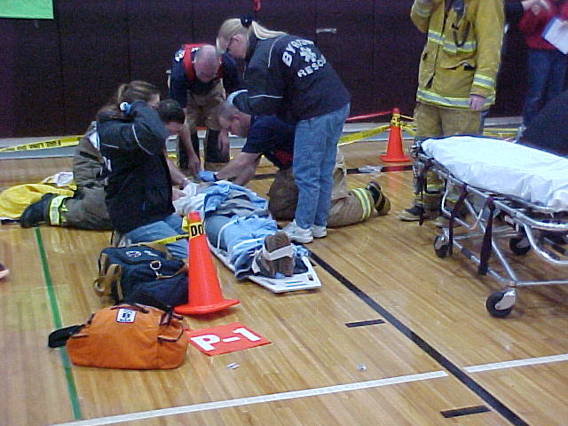
Photo 5 – Triage station |  | Photo 6 – Injured student being attended to.

